Serial Numbers | Control Model Numbers | Control Types² | Firmware Levels |  | Release Dates¹
50000 – 52xxx | System 10  System 20³ | M (Mill) | P0040 – P0053 (System 10M Mill)  P10xx (System 10AM Mill)  P30xx (System 10AM Mill, Non-CMOS)  P35xx (System 10AM Mill, CMOS)  P45xx (System 20 Mill) |  | 12/2/81 – 11/14/83  11/10/82 – 10/16/85  8/6/84 – 12/23/87  10/15/84 – 12/23/87  6/26/85 – 9/22/87
50000 – 52xxx | System 10  System 20³ | T (Lathe) | P20xx (System 10T Lathe)  P25xx (System 10T Lathe, CMOS) |  | 10/10/83 – 7/23/84  10/25/84 – 7/14/86
50000 – 52xxx | System 10  System 20³ | C (Clutch Drive) | P4505, P4506, P4514, P4517 (System 20 Clutch Drive) |  | 11/21/85 - 9/4/86
55000 – 55xxx | Delta 10 | M (Mill) | P40xx (Delta 10 Mill, S20 Hardware) |  | 10/3/86 – 2/29/88
60000 – 67xxx | Delta 10  Delta 20 | M (Mill) | P55xx (Delta 10 Mill, 6 MHz)  P56xx (Delta 10 Mill, 6 MHz)  P50xx (Delta 20 Mill, 6 MHz)  P51xx (Delta 20 Mill, 6 MHz) |  | 12/23/86 – 12/2/88  10/20/88 – 12/17/92  10/6/86 – 3/1/90  12/12/88 – 2/15/94
60000 – 67xxx | Delta 10  Delta 20 | M (Mill) | P57xx (Delta 10 Mill, 12,MHz)  P58xx (Delta 10 Mill, 12 MHz Chinese)  P52xx (Delta 20 Mill, 12 MHz)  P53xx (Delta 20 Mill, 12 MHz Chinese) |  | 10/9/90 – 7/21/95  1/27/92 – 4/9/92  10/1/90 – 4/19/96  1/27/92 – 4/8/92
60000 – 67xxx | Delta 10  Delta 20 | T (Lathe) | P75xx (Delta 10 Lathe, 6 MHz)  P76xx (Delta 10 Lathe, 6 MHz)  P70xx (Delta 20 Lathe, 6 MHz)  P71xx (Delta 20 Lathe, 6 MHz) |  | 2/19/87 – 10/2/91  1/18/89 – 3/8/90  2/18/87 – 6/13/89  5/30/89 – 2/27/91
60000 – 67xxx | Delta 10  Delta 20 | T (Lathe) | P77xx (Delta 10 Lathe, 12 MHz [TS])  P72xx (Delta 20 Lathe, 12 MHz)  P73xx (Delta 20 Lathe, 12 MHz Chinese) |  | 1/23/91 – 3/28/94  10/15/90 – 12/14/96  1/28/92 – 4/9/92
60000 – 67xxx | Delta 10  Delta 20 | C (Clutch Drive) | Px5106 & Px5107 (Delta 20 Clutch Drive, 6 MHz) |  | 9/27/89 – 11/12/92
60000 – 67xxx | Delta 10  Delta 20 | P (Punch) | P60xx (Delta 20 3/4 Axis Punch, 6 MHz)  P65xx (Delta 20 Punch, 6 MHz)  P66xx (Delta 20 2 Axis Punch, 6 MHz)  P67xx (Delta 20 3/4 Axis Punch, 6 MHz)  P68xx (Delta 20 OEM Punch 6 MHz) |  | 10/29/86 – 3/4/87  6/3/87 – 8/22/89  1/9/89 – 1/23/90  1/6/89 – 2/15/90  10/10/89 – 9/27/90
60000 – 67xxx | Delta 10  Delta 20 | P (Punch) | P69xx (Delta 20 OEM Punch 12 MHz) |  | 10/9/90 – 3/24/95
60000 – 67xxx | Delta 10  Delta 20 | AB (Auto Bend) | P8500 (Delta 10 Auto Bend, 6 MHz)  P8600 (Delta 10 Auto Bend, 6 MHz) |  | 12/9/87 – 12/30/91  1/6/89 – 12/27/91
10000 – 10xxx | Delta 30 | M (Mill) | 001.00x.xx (Delta 30 Mill, 25 MHz) |  | 6/20/91 – 12/4/96
10000 – 10xxx | Delta 30 | P (Punch) | xx2.00x.0x (Delta 30 Punch, 25 MHz) |  | 4/2/93 – 10/24/95
20001 – 24xxx | Delta 40/50/60 | M (Mill)  P (Punch)  T (Lathe) | yy1.I0x.xx (Delta 40/50/60 Mill)  yy2.I0x.xx (Delta 40/50/60 Punch)  yy3.I0x.xx (Delta 40/50/60 Lathe) | yy = Language prefix | 6/15/95 – 1/26/00  12/17/98 – 8/30/01
30011 – 30xxx  35000 – 35xxx | Delta 1000/2000 | M (Mill)  P (Punch)  T (Lathe) | yy1.D0x.xx (Delta 1000/2000 Mill)  yy2.D0x.xx (Delta 1000/2000 Punch)  yy3.D0x.xx (Delta 1000/2000 Lathe) | yy = Language prefix | 10/2/00 – 9/28/01  9/30/02 - present

- Release Dates reference when the software was released and only approximate ship dates for control systems.
- If, on the control serial number tag, the model number has the letters ‘MCP’ appended (i.e. D40MCP), the unit shipped as a Machine-Control Package, which included the control, servo drives, motors and cables, and associated electrical equipment, all provided in a cabinet, usually with a pendant arm. The letter ‘E’ (i.e. D20ME) indicates the control was provided in a single enclosure, but without servo drives or motors, or any other electrical equipment. The letter ‘U’ (i.e. D50MU) indicates that the control was provided ‘unbundled’ as a card rack and a separate front panel.
- DynaPath Systems, Inc. no longer supports System 10 or System 20 controls. New or refurbished parts are not available for these systems and DynaPath is unable to provide any technical support.

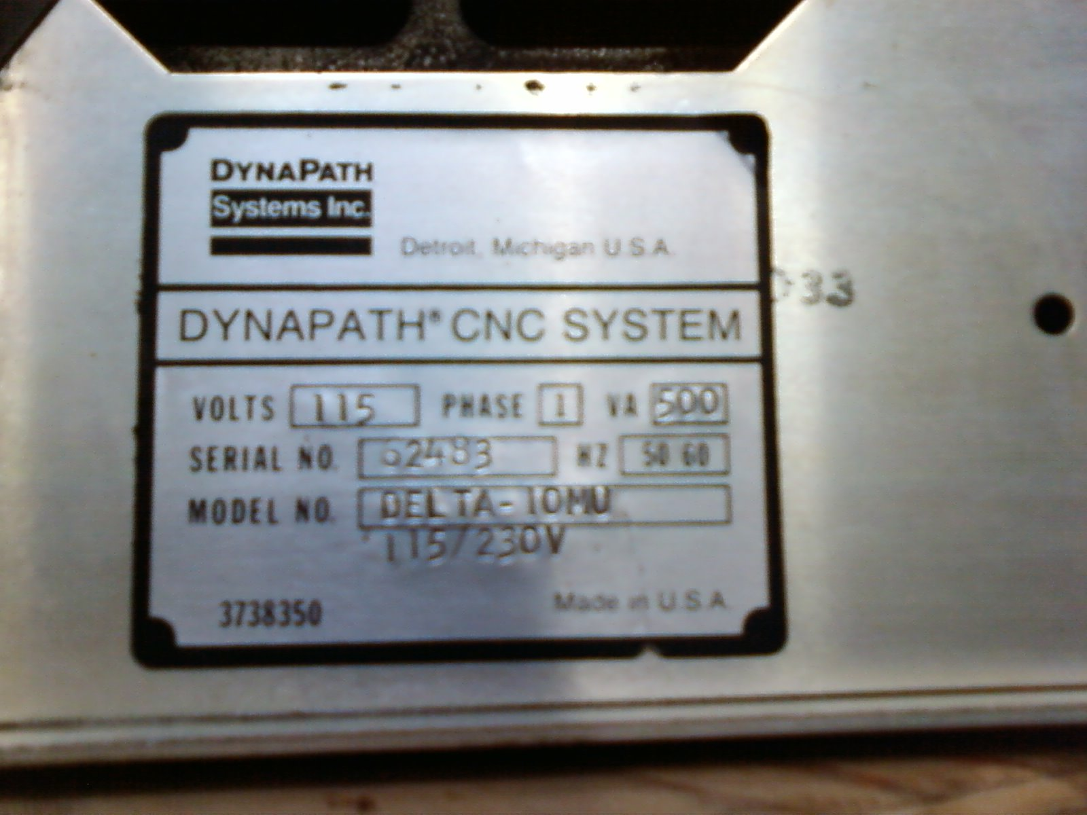

Example Control Serial Number Tag: Delta 10 Mill Control (Unbundled), S/N 62483

